**79655299**

Base URL:

**http://www.neptjournal.com/**

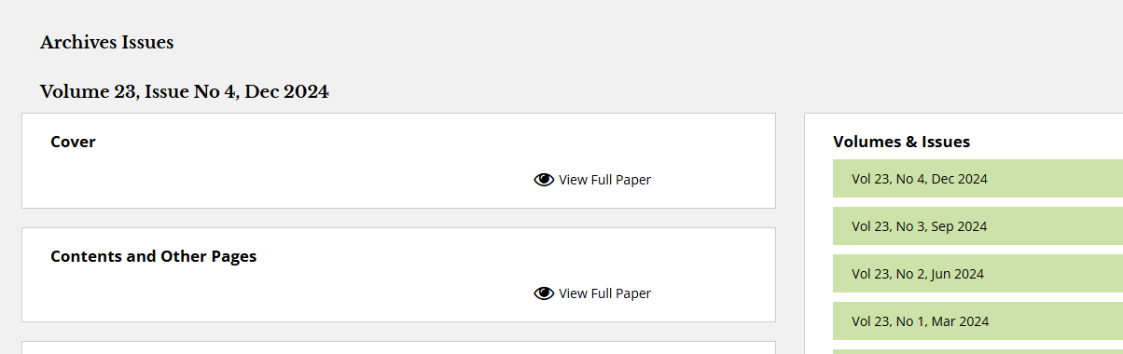

**Select the Current issue from here.**

* Meta data can be captured as below.

**Volume, Issue Month and Year**





**DOI**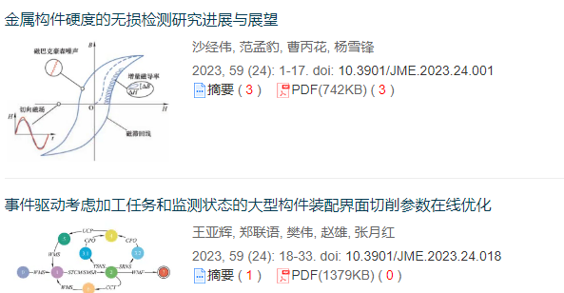

**Article Name**

**Click here to download the pdf**



**Page range**